Zoom Virtual Background Upload Instructions
- Click on the Zoom icon in your computer tool bar.
- The following page should appear

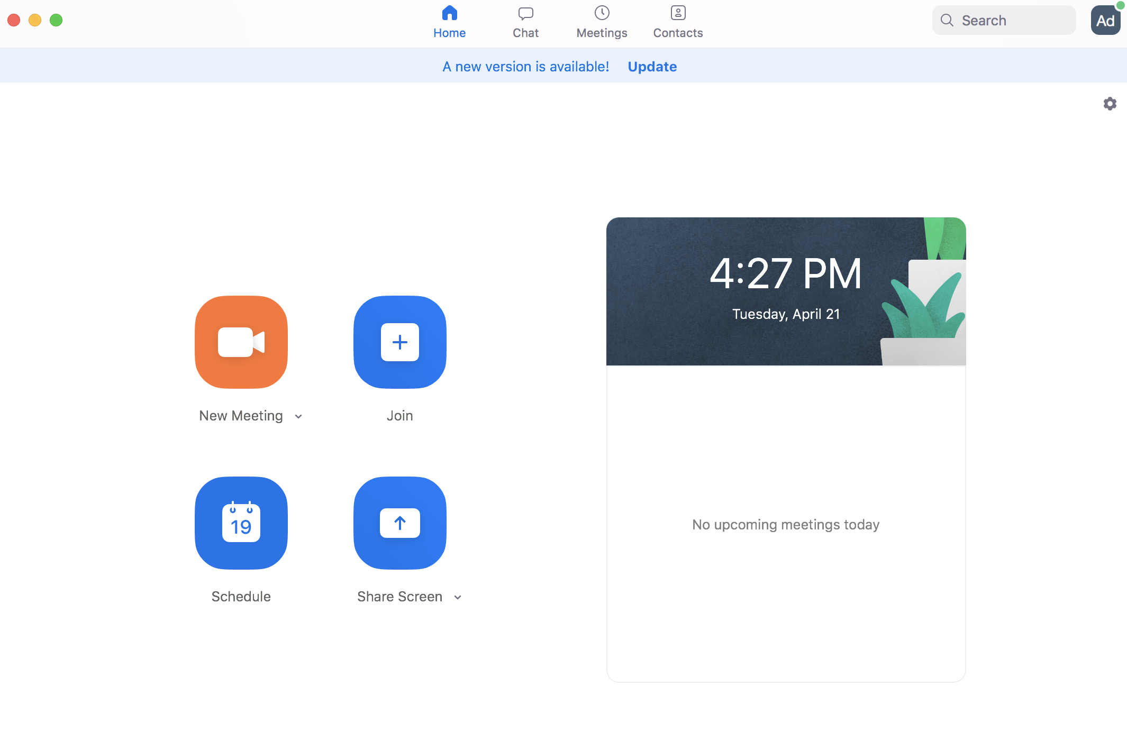
- Click on your initials on top right-hand side of the page (In this example, the “Ad” in the corner of the image above).
- Click on Settings in the drop-down menu that appears.
- The following page should appear
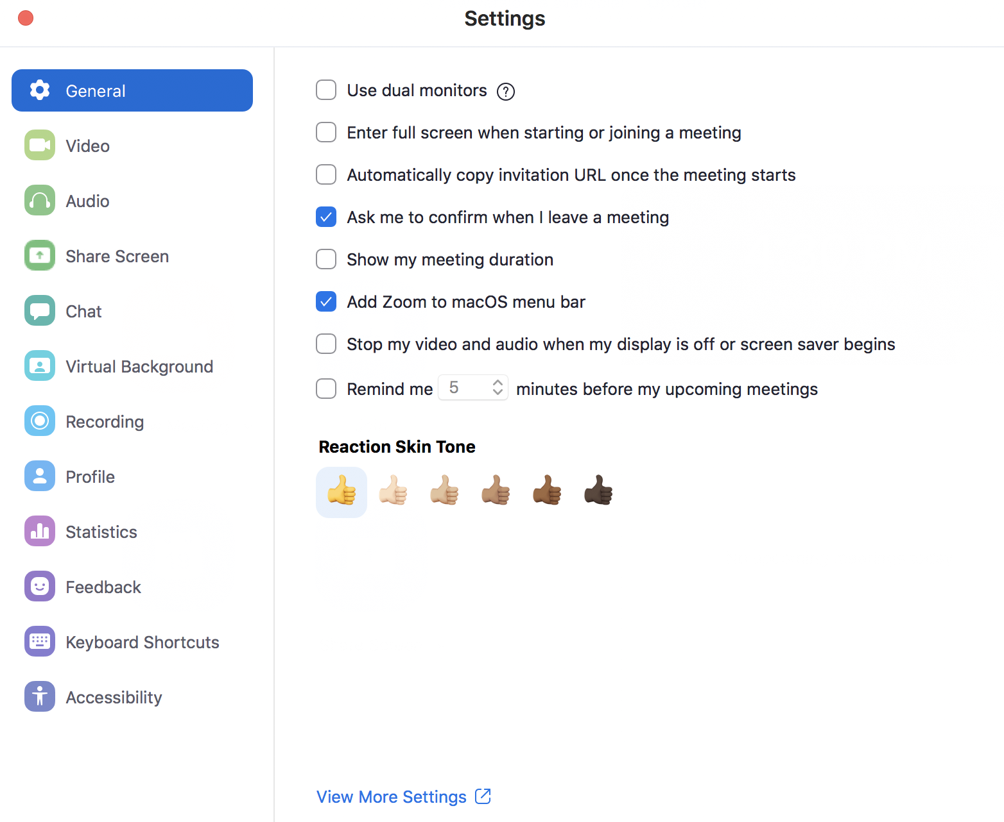

- Click on Virtual Background, on the panel on the left-hand side.
- Once you see the option to adjust your background, click on the plus sign situated slightly above the offered background options. Here you can upload the branded background you’ve downloaded from the Brand Center.
- Make sure to un-check the I have a green screen and Mirror my video buttons at the bottom of the page.

System Requirements
PC Requirements
- Image only without a physical green screen
  - Option 1
    - Zoom Desktop Client for PC, version 4.4.53582.0519 or higher
    - Windows 7, 8, or 10 64-bit
    - 4th generation i7 quad-core or higher processor
  - Option 2
    - Zoom Desktop Client for PC, version 4.5.4 (5422.0930) or higher
    - Windows 10 64-bit
    - 6th generation Intel i5 Dual core or higher processor
    - If CPU is not i7 quadcore or higher, integrated GPU enabled and integrated GPU's graphics driver version 23.20.xx.xxxx or higher
Note: Due to issues with compatibility with Intel CPUs using the HD 620 graphics processor, devices using those processors, must use a physical green screen.
- Image only with a physical green screen
  - Zoom Desktop Client for PC, version 3.5.53922.0613 or higher
  - Dual Core 2Ghz or Higher (i5/i7 or AMD equivalent) processor
- Video or image without a physical green screen
  - Zoom Desktop Client for PC, version 4.6.4 (17383.0119) or higher
  - Windows 7, 8, or 10 64-bit
  - Supported processor
    - 6th generation i5 quad-core or higher, except u-series
    - 4th generation i7 quad-core or higher
    - Any processor with a logical core of 8 or higher and frequency of 3.0GHz or higher
- Video or image with a physical green screen
  - Zoom Desktop Client for PC, version 4.6.4 (17383.0119) or higher
  - Windows 7, 8, or 10 64-bit
  - Supported processor
    - 6th generation i5 dual-core or higher processor, except atom and y-series
    - i5 quad-core or higher processor
    - Any processor with a logical core of 6 or higher and a frequency of 3.0GHz or higher
Mac Requirements
- Image only without a physical green screen
  - Zoom Desktop Client for Mac, 4.6.0 (13614.1202) or higher
  - 4th generation i7 quad-core or higher processor
  - 6th generation i5 dual-core or higher processor
Note: 6th generation i5 dual-core processor, requires MacOS 10.14 or higher
- Image only with a physical green screen
  - Zoom Desktop Client for Mac, version 3.5.53922.0613 or higher
  - Dual Core 2Ghz or Higher (i5/i7 or AMD equivalent) processor
- Image or video without a physical green screen
  - Zoom Desktop Client for Mac, version 4.6.4 (17383.0119) or higher
  - macOS 10.9 or later
  - Supported processor
    - i5 quad-core or higher
    - 6th generation i7 dual-core or higher, with macOS 10.14 or later
    - Any processor with a physical core of 8 or higher
- Image or video with a physical green screen
  - Zoom Desktop Client for Mac, version 4.6.4 (17383.0119) or higher
  - macOS 10.9 or later
  - Supported processor
    - 6th generation i5 dual-core or higher processor, except atom and y-series
    - i5 quad-core or higher processor
    - Any processor with a physical core of 8 or higher
Linux Requirements
- Zoom Desktop Client for Linux, version 2.0.91373.0502 or higher
- Dual Core 2Ghz or Higher (i5/i7 or AMD equivalent) processor
- A physical green screen
iOS requirements
- Zoom Mobile App for iOS, version 4.1.27541.0627 or higher
  - iPhone 8, 8+, or X
  - iPad Pro and the 5th and 6th generation iPad 9.7

1300 York Avenue, New York, NY 10065

